**Group Boat Project Report**

**ENGEN180-18A**

**Foundations of Engineering**

Team Members

**Dion Herniman - 1346553**

**Tony Carpendale - 1286411**

**Lee Oldfield - 1349803**

**Nashlin Sharma - 1341382**

**Sultan Al-Habsi -**

**Alaa Eldin Abuellif - 1260323**

**Kieran West - 1349084**

**Rojena Fuentes – (no longer enrolled in course)**

Syndicate Managers

**Ben Thornton**

**Russell Keenan**

**Syndicate E**

**Date: 02/06/18**

# 1CONTENTS

1. Abstract – (Dion) ……………………................................................................................3
2. Introduction – (Dion) ……………………...........................................................................3
3. Step by Step Design Process .........................................................................................4
   1. Hull- (Dion) ...............................................................................................................4
   2. Vacuum Forming process – (Dion) ..........................................................................6
   3. Rudders & Steering – (Tony & Lee) .........................................................................7
      1. Research...........................................................................................................7
      2. Experimental Results.........................................................................................8
      3. Concept Sketches..............................................................................................8
      4. Concept Development.....................................................................................10
   4. Motors & Propulsion – (Nashlin) ............................................................................10
   5. Batteries – (Kieran) ................................................................................................12
   6. Collection System – (Alaa Eldin & Sultan) .............................................................15
4. CAD Drawings – (Nashlin) ............................................................................................19
5. Costings – (Tony)...........................................................................................................20
   1. Materials and Budgeting ........................................................................................20
   2. Accounting for Hours and Material Cost ................................................................22
   3. Mass Production ....................................................................................................23
6. Environmental Considerations - (Alaa Eldin & Sultan)…...............................................24
7. Performance Appraisal -(Lee) .......................................................................................25

# 2ABSTRACT – Dion Herniman

# The aim of this project was to build a RC model boat with the ability to collect plastic waste from Oranga lake. The given budget was $210 and the boat had to be built in five, two-hour lab sessions with a one-hour extra lab which totalled eleven hours. Team members were assigned to design and build each part of the boat; the hull, propeller and motor, rudder and steering, battery pack and the collection device. Each part of the boat went through the design and manufacture process. The hull design chosen was the wide hull, the full rudder was chosen, we decided to have 3 propeller blades with a pitch of 35°, the battery packs were decided to be 2 packs of 6 volts connected in parallel and for the collection device we decided the design B would be the best method of collecting plastic waste from the lake. The final touches on the boat were finished during the final 1-hour bonus lab. Our boat performed very well on race day allowing us to come first place among the students and defeat the teachers boat, we can attribute this win towards all parts of the boat doing working well together.

# 3INTRODUCTION – Dion Herniman

The lab sessions for this paper focused on the build of a boat in the large-scale laboratory. Any necessary knowledge to build the boat adequately was taught to us in different activities during the first 2 laboratories and we also had 2 labs on learning CAD. However, additional information research was highly recommended and will act on the quality of the boats. It was decided to attribute specific task to each member's. The different tasks were: The motors and propulsion, the battery packs, the rudder and steering system, the hull and the collection device. Each task required different approaches. The main decisions were discussed during the preceding meetings.

## 4STEP BY STEP DESIGN PROCESS

4.1 Hull - Dion Herniman

The hull is the essential watertight compartment that not only provides structural integrity for the boat, but it is also the main area of interaction between the water in which it travels and the vessel itself. Therefore, the boat should be a design that is a compromise between hydrodynamic qualities and volume that allows the internal workings to fit and have sufficient space to function. The hull mainly impacts upon speed, space, stability, manoeuvrability, and the collection device.

This year we were not able to design our own hull, instead we were given 5 default hull types to choose from which were a narrow hull, a standard hull, a wide hull, a barge hull and a catamaran.

We decided to not go with the catamaran since it would cost a lot more than the other boat types as well as the fact that it would require a lot more work as well. Therefore, the catamaran was not added in the matrix of **Figure 4**.

The top speed of the boat depends upon the power of the motor, hull shape, and wet surface area of the hull. The drag force caused by the water around the hull is known as the hull drag. At the start of the semester, hull drag experiments were conducted in the lab on 4 of the 5 possible hull shapes to determine the drag coefficients at different water velocities, the one type we didn’t get to test was the catamaran. We also learned about the different boat hull shapes and how the differences in shape affect the drag. **Figure 1** shows the drag versus fluid velocity graph of the hull models tested in lab by the students.

Figure 1 Graph of Drag vs Fluid Velocity

Unlike previous years the boats this year do not focus primarily on racing, they focus on collecting plastic waste from the lake due to this speed isn’t as important a factor as in previous years instead space, stability, manoeuvrability are more important when it comes to choosing a hull. Because the collection device and potential plastic waste will drastically increase the drag and weight of the boat, stability becomes a highly important factor as seen in **Figure 2**. Having a high manoeuvrability will also make it easier to collect plastic waste.

|  |  |  |  |  |  |  |
| --- | --- | --- | --- | --- | --- | --- |
| **Criteria** | **A** | **B** | **C**  Figure 2 Criteria matrix | **D** | **Total** | **Rank** |
| **A Speed** |  | 1 | 0 | 0 | 1 | 3 |
| **B Drag** | 0 |  | 0 | 0 | 0 | 4 |
| **C Space** | 1 | 1 |  | 0 | 2 | 2 |
| **D Stability** | 1 | 1 | 1 |  | 3 | 1 |

|  |  |  |  |
| --- | --- | --- | --- |
| **Criteria** | **Rank** | **Score** | **Weight** |
| **D Stability** | 1 | 3 | 0.5 |
| **C Space** | 2 | 2 | 0.3 |
| **A Speed** | 3 | 1 | 0.15 |
| **B Drag** | 4 | 0 | 0.05 |
| Figure 3 weighting matrix |  | Sum=6 | 1.0 |

|  |  |  |  |  |  |
| --- | --- | --- | --- | --- | --- |
| **Criteria** | **Weighting** | **Narrow(%)** | **Standard(%)** | **Wide(%)** | **Barge(%)** |
| **D Stability** | 0.5 | 20 | 40 | 80 | 85 |
| **C Space** | 0.3 | 20 | 40 | 80 | 85 |
| **A Speed** | 0.15 | 80 | 70 | 50 | 20 |
| **B Drag** | 0.05 | 80 | 75 | 50 | 30 |
| Figure 4 | 1.0 | 32 | 46.25 | 74 | 72.5 |

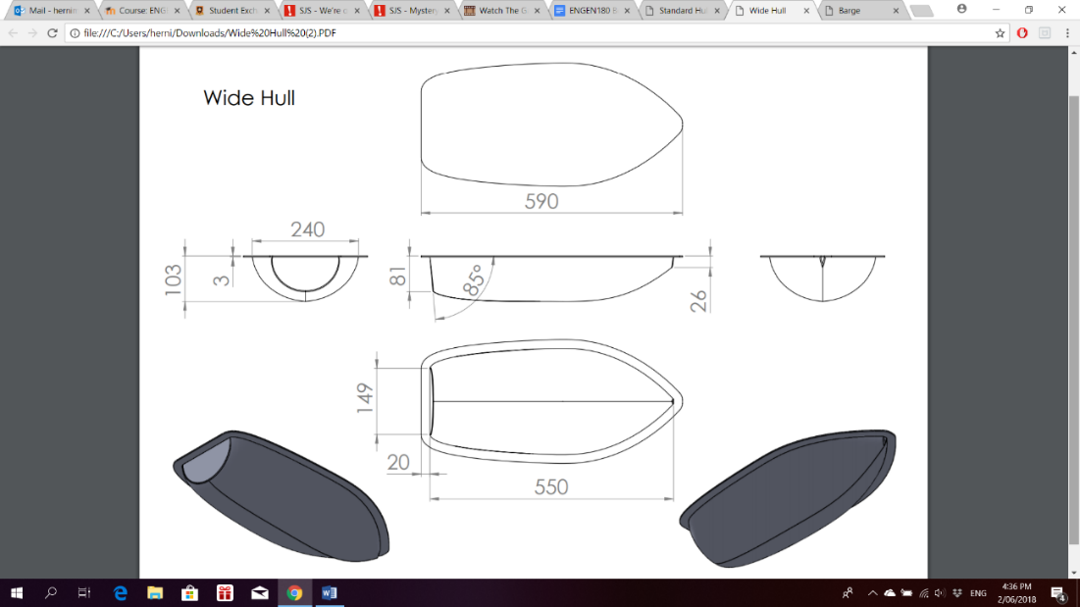Based on the above matrices the best hull that fits our requirements is the wide hull (**Figure 5**). The wide hull has the stability to withstand having the weight of a collection device added onto it and the space to easily fit two battery packs while still having the ability to go at a reasonable speed. It also only has a middling level of drag at the lower speeds the boat will driving at.

Figure 5 Wide Hull

4.2 Vacuum forming process – Dion Herniman

The polyethylene terephthalate glycol (PETG) sheet which is to be formed is inserted into the clamp area on the machine in its cold state. This PETG sheet is then heated uniformly over the entire surface area and throughout its thickness to the desired temperature using a surface heater. Once the plastic is heated and softens, it is then draped over the mold. During this time a vacuum is applied sucking the sheet onto the mold and to remove the air trapped between them. Once the plastic is formed to the required shape it is left to cool. To shorten the time for cooling a fan can be used. Releasing the part before cooling can cause deformation and part rejection. The cooled plastic along with the mold is removed from the vacuum system and by applying a reverse pressure the formed plastic is ejected from the mold. **Figure 1** illustrates a vacuum forming process very similar to the one we used in the Lab.

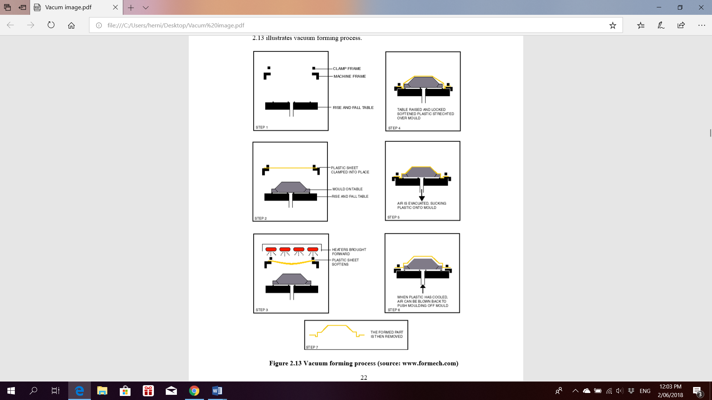

Figure 1

**Figure 1 Vacuum forming process (source:** [www.formech.com](http://www.formech.com)**)**

4.3 Rudders & Steering – Tony Carpendale & Lee Oldfield

4.3.1 Research – Lee Oldfield

To optimise the steering efficiency there were many important factors considered in connecting the rudder and servo. We decided that a push rod connection was going to be the best option as it meant we could use a shallower water tight compartment, hence freeing up more space for other components inside the hull. It also provided a more reliable connection that was both cheaper and easier to build. The servo was placed on its side inside the water tight compartment with 3 of the 4 horn protrusions trimmed off to allow for free rotation, and to maximise the total rudder movement. We also mounted the push rod 10mm from the hinge of the rudder to optimise turning capacity as further away would decrease the rotational movement of the rudder. To do so, an aluminium strip (tiller arm) was cut with multiple holes drilled to allow for fine adjustment.

Two materials were considered when constructing the rudder, aluminium sheet and 6mm plastic. The advantage of using the aluminium sheet is that it is very thin and light, hence it has a very low drag in the water. However, aluminium sheet is only about 1.5mm in thickness which has a tendency to flex very easily. On the other hand, the 6mm plastic has the advantage of being very sturdy with no chance of flexing in the water. However, it is of greater thickness and weight hence causing more drag in the water. When finalising our design, we decided that the plastic rudder was going to be the best option as it provided a very reliable steering mechanism that had a low chance of failing. To reduce the drag, we shaped the front of the rudder into a hydrodynamic shape to help decrease water resistance.

4.3.2 Experimental Results – Lee Oldfield

The length and width of the rudder are also important factors to consider when designing the rudder. The longer the rudder, the more surface area in contact with the water, and hence a greater turning radius. However, a larger rudder results in a larger drag force. Based on our lab experiment (Figure 1), a larger full-sized rudder was proven to be the best as the average turning distance was noticeably smaller than the other two sizes. By hydrodynamically shaping the rudder at its front edges, this reduces the width of the rudder dramatically and therefore making it more hydrodynamic through the water.

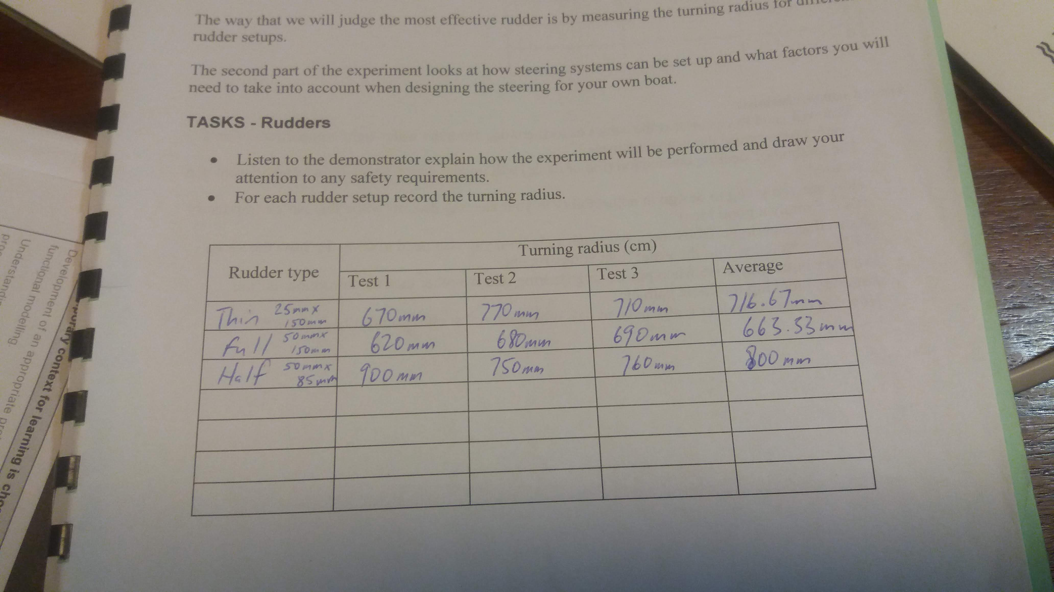

Figure 1: Rudder turning radius test results

4.3.3 Concept Sketches – Tony Carpendale

The concept sketches below on the left (refer to Figure 2) - show consideration of different rudder shapes and pivot arrangements, the sketch on the right (refer to Figure 3) - shows the pivot point on the rudder in relation to the rudder mount 2/3 from the back edge of the rudder and 1/3 from the front edge. This enables the leading edge of the rudder to catch more thrust from the propeller wash by pivoting over the centreline of the propeller and drive shaft, enabling a more effective turn.

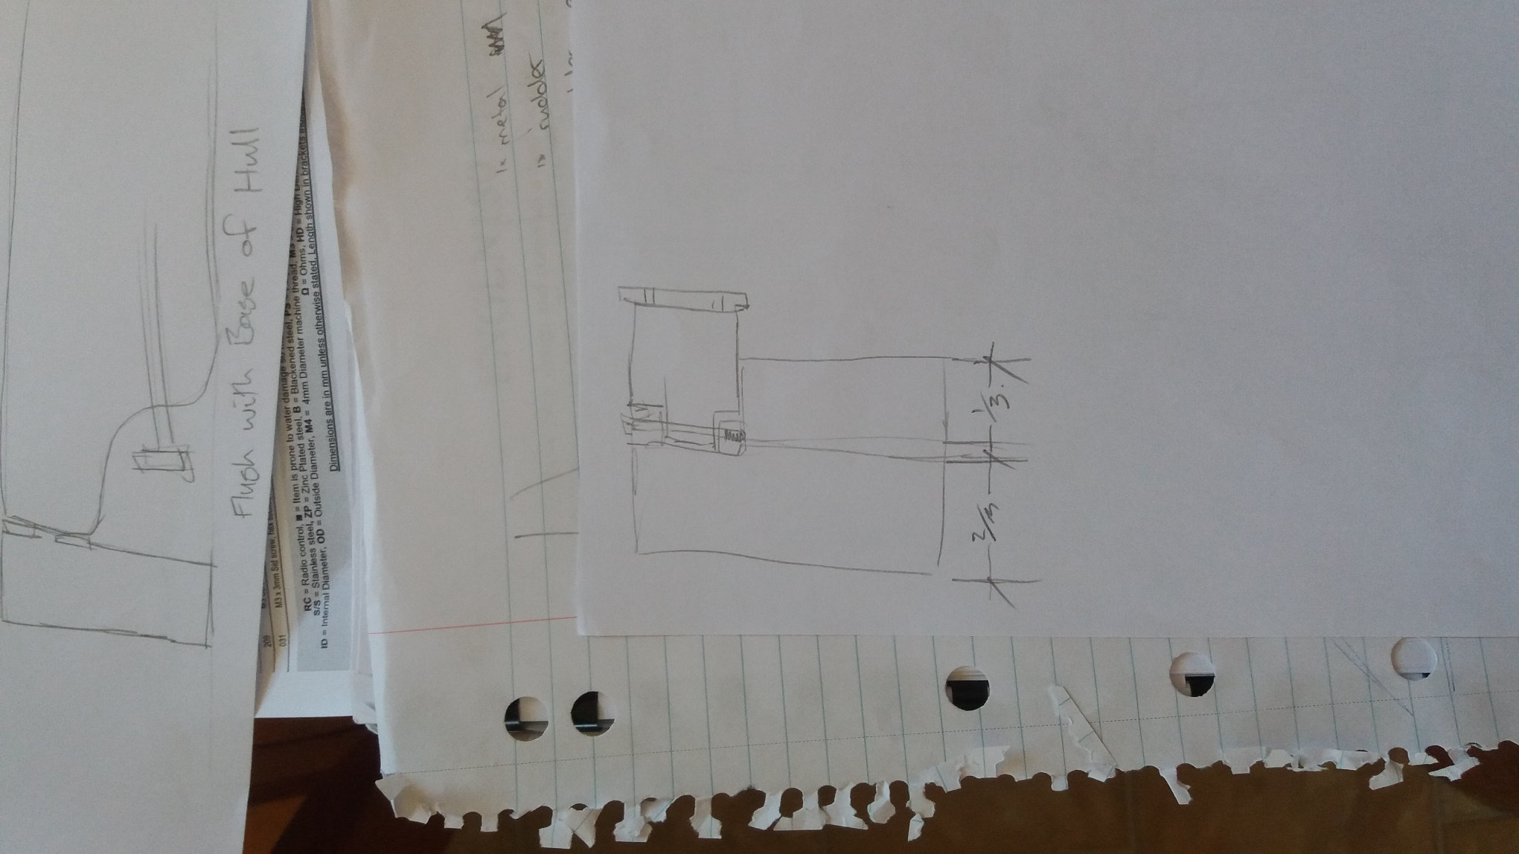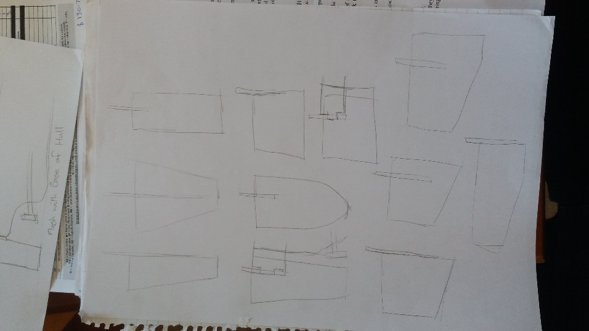

Figure 3: Proposed pivot point

Figure 2: Rudder shapes

The sketch below (refer to Figure 4) – shows how the rudder catches more of thrust from the propeller having a greater turning effect.

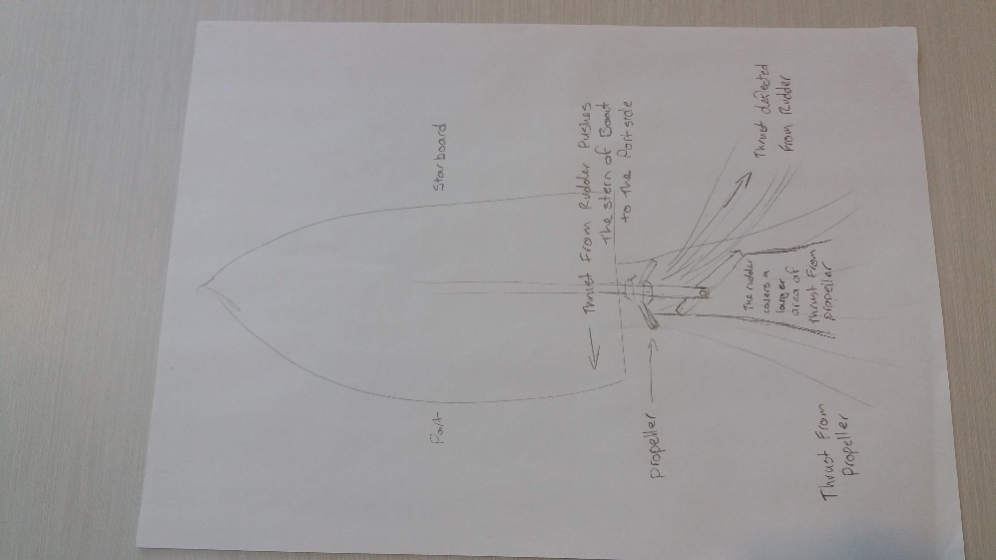

Figure 4: Propeller thrust on rudder

Figure 5 below displays consideration of varying rudder depths in relation to the keel of the boat. Figure 6 displays consideration different rudder profiles and different pivot points looking from down from a top elevation view.

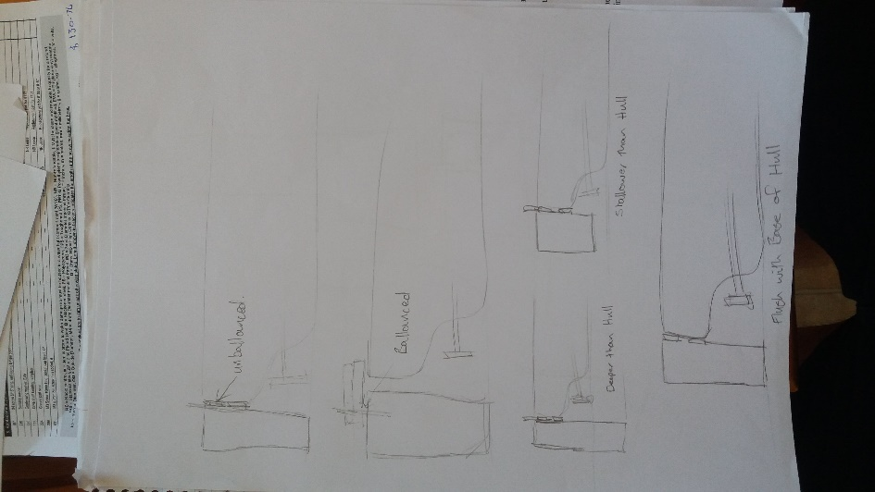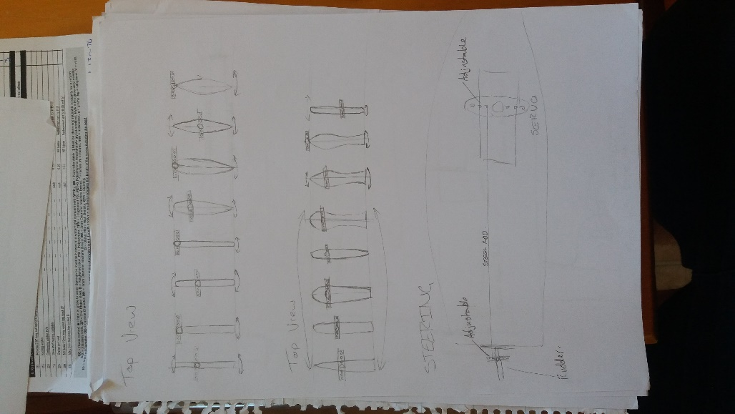

Figure 5: Rudder depths

Figure 6: Rudder profiles

There were two types of steering methods available to choose from, either a pull method provided by a cable assembly setup or a push pull rod assembly setup. Both systems are linked to a servo (refer to Figures 7 and 8 below).

The cable linkage system is an effective method to use. It provides responsive steering control by having tension on both cables set just right. However, consideration of the fabrication time, cable orientation and tight allocation of build time was a big factor in deciding which method Syndicate E was going to use.

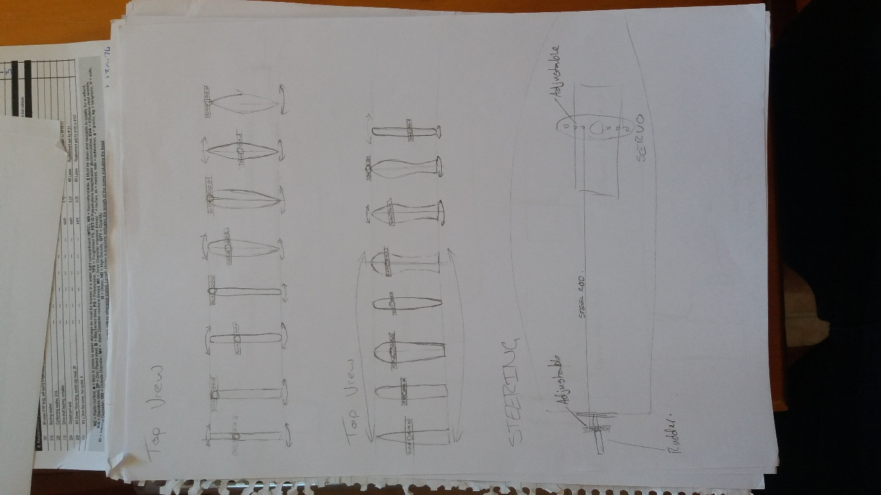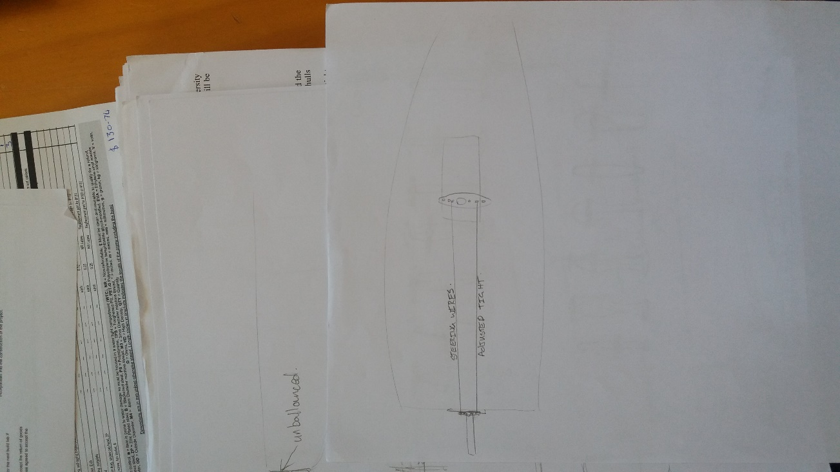The push rod method allows for easy adjustment of the rudder simply by selecting one of the adjustment holes on the tiller arm and by having one end of the push rod threaded to allow for adjustment on the linkage clevis. This design was the most favourable due to the easy of adjustability and time to fabricate the assembly. Having multiple adjustment holes on the tiller arm allowed for quick and easy adjustment of the steering radius.

Figure 8: Push rod assembly

Figure 7: Cable steering arrangement

4.3.4 Concept Development – Tony Carpendale

Below is a concept development of our proposed rudder and assembly and attachment to the transom of the boat (refer to Figure 9). This shows adjustment holes on the tiller and the concept of threaded adjustment on the push rod.

Multiple holes on the tiller arm to allow for turning radius adjustment of the boat.

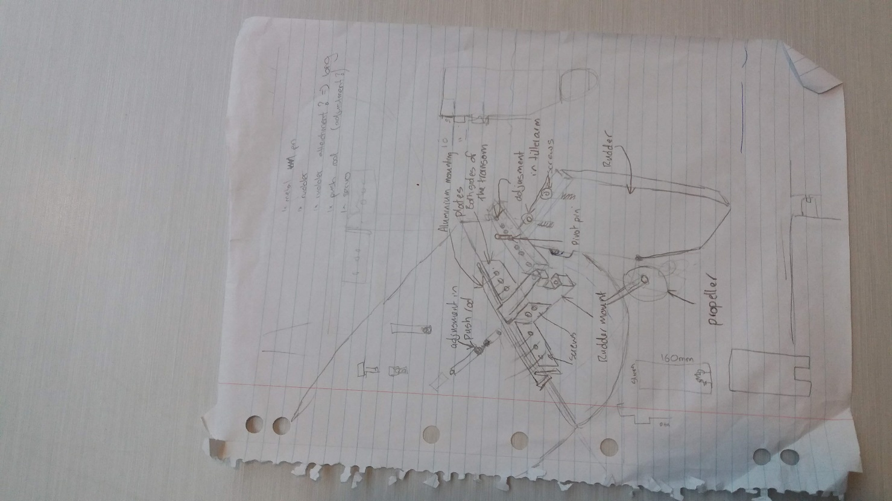

Threaded adjustment on the steering push rod.

Extra reinforcement may be necessary when attaching the rudder mount to the transom. This depends on the strength of the vacuum formed hull, which at the time of concept development this was unknown.

‘

Figure 9: Concept Development

The dimensions of materials available for use from Brett’s Bargain Basement had direct effects on the overall size of the rudder components, and throughout the build process parts of the design were modified as and when required to enable a nice and strong rudder setup.

4.4 Propulsion – Nashlin Sharma

To be able to compete on race day, our boat had to have the potential to be able to participate in the race day as well as collect the maximum amount of plastic rubbish to earn maximum points to win. Compared to the previous years of the boat races speed was the main goal but this year since the boat would have to be able to collect enough rubbish, maximum amount of speed wasn’t required but the speed should be at a certain level to be able to carry the weight of the rubbish. Propeller blades have variations as they can be a certain size, blades that are being used and the pitch of the blade. Based on the results on the diagram below we have concluded with the propeller design with 3 propeller blades along with the pitch of 35° with the overall length of the drive shaft of 270 mm.

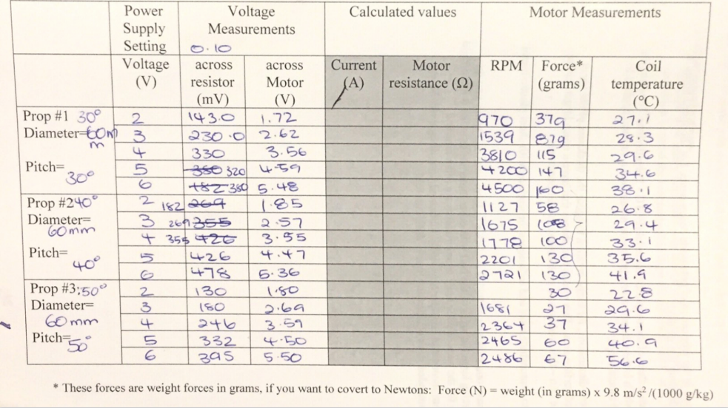

The decision of using a 35° pitch was concluded as in activity 2 propeller types and motors where we did experiments regarding the three pitches of 30°,40° and 50° which showed and gave ideas as to which blade pitch would be ideal for our boat. It was a decision between 30° and 40° as the 50° wasn’t the ideal pitch because it gives a high coil temperature along with high RPM along with producing greater pressure which is what we weren't looking for. So therefore 30° and the 40° pitch fit perfectly within our requirements. Since the pitch is adjustable it really doesn't matter which pitch is used but we ended up choosing 35° as our blade pitch as the 40° had the lowest RPM average of 1900.4 RPM whereas 30° had the highest force average of 109.2 grams. So, we choose to go in between these two pitches. Also, the 30° and the 40° pitch have a slightly less high coil temperature which means that the motor would not be likely to burn out during the race.

Using 3 blades for the propeller gives the best performance compared to using either two or four blades and using 3 blades is the safest option. Having 3 blades gives that extra speed that will be useful when the boat has got the weight of the rubbish on it. If we have used 2 blades and the weight is added on then it would require a lot of force for the boat to move and it would be slow as well. The overall length for the drive shaft was 270 mm as we cut 125 mm of the propeller. Also, we used the two-thumb rule between the two universal joints inserts which was needed as there is liquid nail both inside and outside the hull.  Then the propeller needs to be connected to the motor.

For keeping the motor and the drive shaft in its place and stop it from moving an aluminium sheet metal plate was mounted on the sides of the motor and draft shaft along with the aluminium sheet metal being mounted on the white sheet plastic on top of the boat so it would be secured enough. Diagrams below indicate the design process, while considering how much weight it can put on the boat as it would have made an exception impact on our boat as we need our boat light as possible so it can be able to take on the weight of the rubbish on race day.

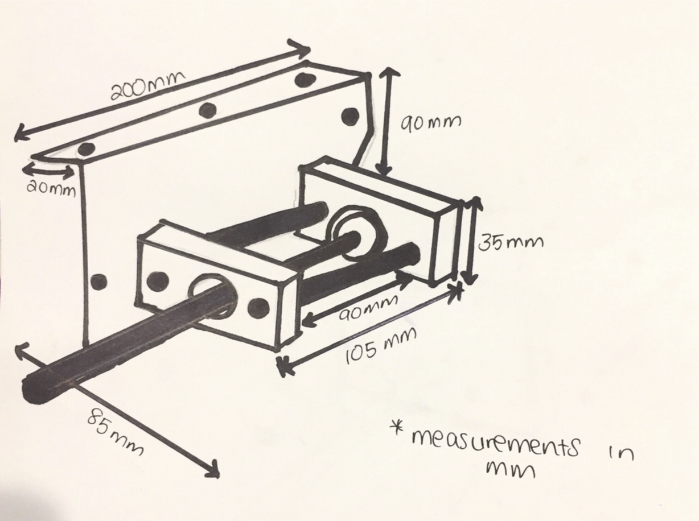

The choices that we had made with our propulsion system turned out to give us some good results. Having the blade pitch at 35° was a great idea as our boat had the ability to get around the course and can collect rubbish and making it back to the edge of the pit at a reasonable time. Which I think we had as an advantage.

4.5 Battery Pack – Kieran West

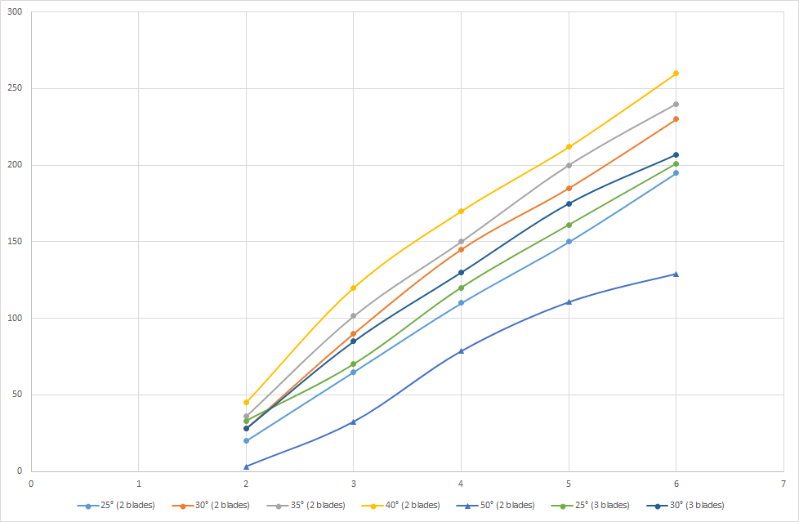It was decided that for our boat we would have 2 packs containing 8 batteries each. The cells were configured so that the two packs were connected in parallel and the two strings inside consisted of 4 cells in parallel. This means that the nominal voltage of each pack will be 6 volts, resulting in 2 packs of 6 volts connected in parallel. From gaining data from the labs prior to the build labs this seemed the best option to drive the motor at due to the races being 5 minutes in length each so it would be ideal to get as much force as possible, whilst keeping as much capacitance. In figure 1 below the highest voltage tested was 6 volts and it produced the largest grams force independent of the angle of the propeller.

*Figure 1:*

*Grams Force vs*

*Motor Voltage*

*graph*

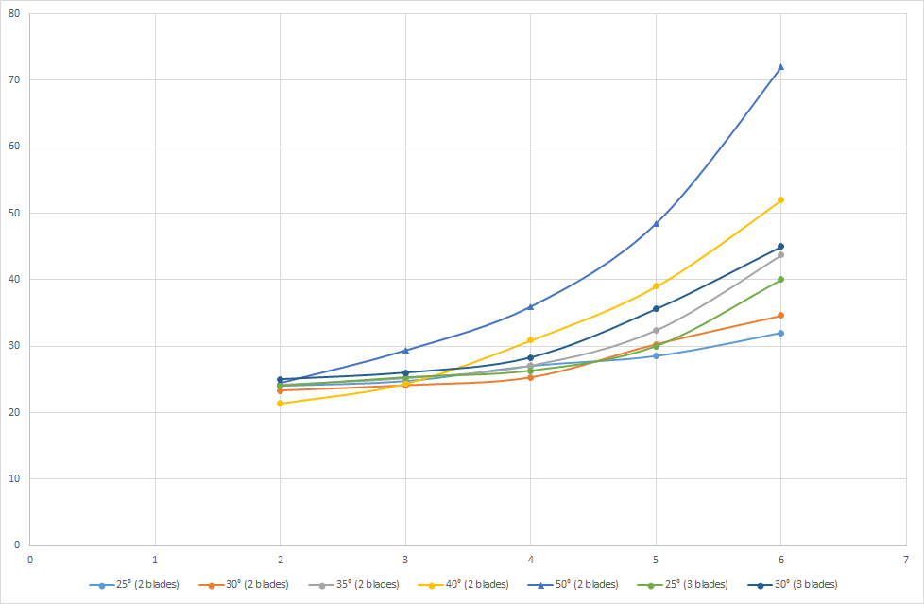

*Figure 2: Temperature vs Motor Voltage graph*

In contrast when looking at the data produced in figure 2, when the voltage in the motor was higher, around 6 volts, there was a large amount of heat in the motor coil. We didn't want this heat to become too great because it could result in some serious damage to the motor and even the boat itself. Even though the chosen nominal voltage chosen for our battery pack outputs was at 6 volts, the highest out of what we tested, which means that it should produce the most heat in the motor. Alternatively, the two strings could have been wired in series and we would have had a nominal voltage of 12 volts but it was decided that heat build-up would be too much of an issue, also the amount of time to be spent on the water is a reasonably substantial 5 minutes each time which means we would need the batteries to be able to run for longer. The last factor that played a part in the configuration of the battery packs was the cost of the batteries and since they were free it made sense to try and fit as many as was reasonable into the packs. So, the decision was made to go with a nominal 6 volts meaning this boat will be suitable for the amount of force through the water needed and managing the temperature of the motor.

Using a battery pack consisting of two parallel strings means that the battery pack can supply more current to the motor, but mainly extending the runtime of the cells. Given that the packs needed to be used for more than one race, the extension of the runtime given by the parallel configuration was desirable and it also means the rate of what the voltage declines at is slower. The parallel configuration of the cells in the packs allows current to be more readily supplied to the motor in that it has a total capacitance of over 25,000 farads between each string which means the burden of a high voltage can be shared between four strings rather than two or one. Therefore, it reduces the strain on the battery pack

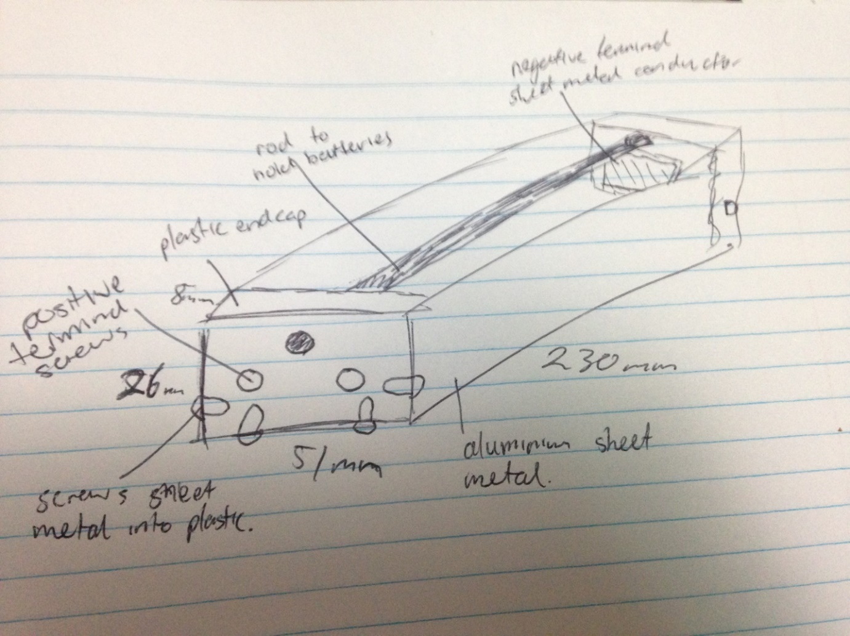

*Figure 3: Final battery pack design sketch*

When it came to designing the enclosure of the batteries into the battery pack factors that were considered were, making sure they could not fall out, less costs, removability from the pack, and how it would affect electrical wiring. The initial design was for there to be two aluminium tubes running parallel to each other on top of the batteries and screwed into both ends of the pack through the plastic. In the final design, to minimise costs, one aluminium tube was screwed in at both ends through the middle of the packs sitting on top of where the two batteries meet so that they are sealed in tightly as well as fitting all the other requirements. After making the sheet metal end cap at the back of the battery pack it was found that the ideal spot to hold the batteries in with the rod was covered by the sheet metal which could not be drilled through, so instead of coming up with a new idea the decision was made to drill above the ideal spot and the result was that it still managed to hold the batteries in place without movement. (refer to figure 3)

The actual size and shape of the pack was largely determined by the amount of batteries that was chosen for the packs. Using a different design with 16 batteries would have been very difficult to make all the electrical connections let alone actually fitting one large pack or four small packs, which would also mean that getting all the cables connected becomes more difficult as well as making the construction of the packs more difficult. The decision was made to go with two packs of 51mm wide, 26mm high, and 230mm long, not including extra protrusions such as screws.

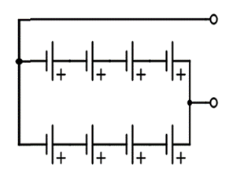To provide connections to the end of the batteries the electrical cables were connected to the large end screws which are connected to the batteries. The plastic end caps were screwed into the side and bottom of the aluminium sheet metal with the small screws. At the non-wired end of the pack was a folded square sheet metal that was glued to the plastic end cap to provide an electrical connection between the batteries and the pack.

*Figure 4: Circuit diagram of the battery packs*

For the electrical connectivity it was considered to be most optimal to have both the positive and negative terminals at the same end for ease of access and wiring. This meant we had to have two separate terminals at the other end of the folded sheet metal so both terminals could be at the same end of the pack refer to figure 4 this shows a similar circuit diagram to the one we had to make with the exception of both terminals being on one end. To run the current from one end of the battery pack to the other we used the electrically conductive sheet metal from the back to run it near the positive terminals. Using the ring crimp connectors, the cables could be directly attached to the positive terminals just by putting the ring connector onto the screw then tightening a nut onto it to keep it in place. When the screw is screwed in fully, the screw clamps the ring connector tightly to the pack and produces a solid electrical connection. The plan for a switch for the motor was originally to use terminal blocks and that was what we ended up going with, due to that it was just easier and more sensible.

4.6 Collection System – Sultan Al-Habsi & Alaa Eldin Abuellif

The challenge of this year was to create a boat that could collect wastes from one of the lakes at the University of Waikato. The team assigned two people to create a collection system that would be able to collect as much waste as possible to win the competition. During the meetings, the group decided to focus on building a simple collection device that is far from any complications due to cost, time and the set of limited materials to work with.  
The collection system is a significant part of the boat, without it the purpose of the boat will not be completed. There were many aspects that needed to be considered while designing the collection system. They were:

Simplicity:

That the design needed to be simple, far from any complications or complex ideas because we had a limited time, budget and materials to build the boat. Therefore, as an engineer's we needed to adjust the ideas to cope with the situation.

Drag:

One of the most important aspects of the collection system is the drag because it reduces the top speed of the boat and so a boat with little drag, which going to help with collecting more wastes in a short time is preferred over a boat with high drag.

Performance and Efficiency: in order to win, we had to create a design that will be able to collect as many wastes as possible in the giving time frame. Therefore, being efficient to collect a large amount of waste is important.

Materials: using the proper materials is important because they have an impact on the boat speed. Using heavy wire with small holes will increase the boat weight and drag causing the speed to decrease. Also, the cost must be considered while choosing the best materials to work with because we have a limited budget.

Designs:  
There were three designs made for the collection system and to choose the best design, a selection matrix was made:

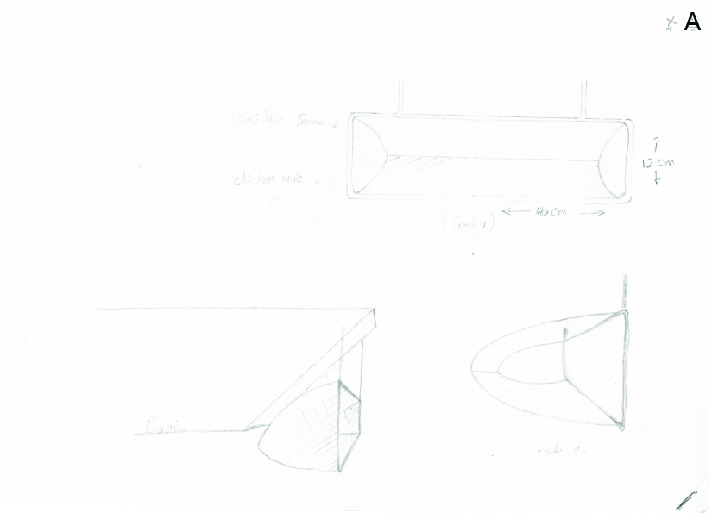

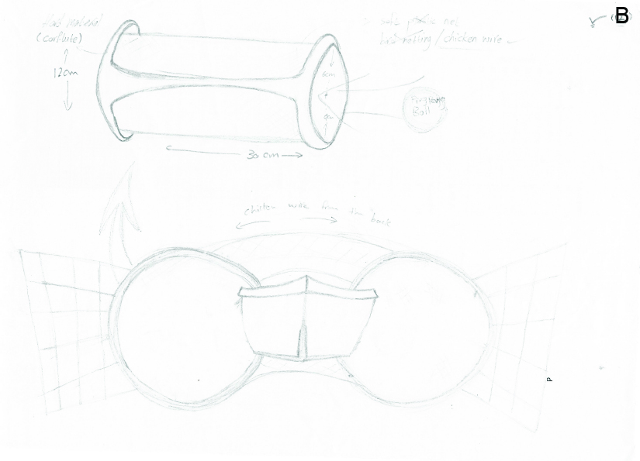

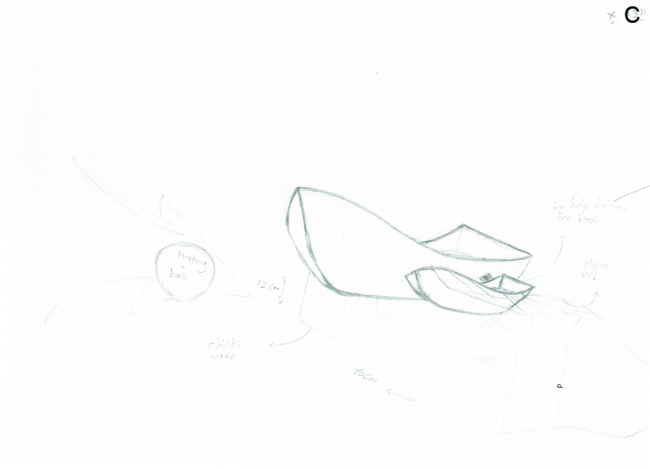

|  |  |  |  |  |  |
| --- | --- | --- | --- | --- | --- |
| **Criteria** | **A** | **B** | **C** | **Total** | **Rank** |
| **Simplicity** |  | 1 | 0 | 1 | 3 |
| **Drag** | 1 |  | 1 | 2 | 2 |
| **Materials** | 0 | 0 |  | 0 | 4 |
| **Performance & Efficiency** | 1 | 1 | 1 | 3 | 1 |

|  |  |  |  |  |
| --- | --- | --- | --- | --- |
|  | **A%** | **B%** | **C%** | **Weight** |
| **Performance & Efficiency** | 70 | 100 | 70 | 0.33 |
| **Drag** | 60 | 90 | 50 | 0.27 |
| **Simplicity** | 90 | 80 | 80 | 0.23 |
| **Materials** | 70 | 80 | 70 | 0.17 |
| **Total** | 71.9 | 89.3 | 68.6 |  |

Design B:

Based on the result from the selection matrix. It is found that design (B) is the best concept to work with. The design will provide a better performance and speed. The idea of the design is having two calendars made from a chicken wire on both sides of the boat, the cylinders are 30 cm long and 12 cm high. In one side of each cylinder, a rectangular shape will be made also with chicken wire and will be attached with the cylinder to give a wider range to collect the trash through in the lake. The reason behind choosing chicken wire is that it has wider spaces and lightweight which will help to minimize drag and contribute in the boat speed. (sultan)

# 5CAD – Nashlin Sharma

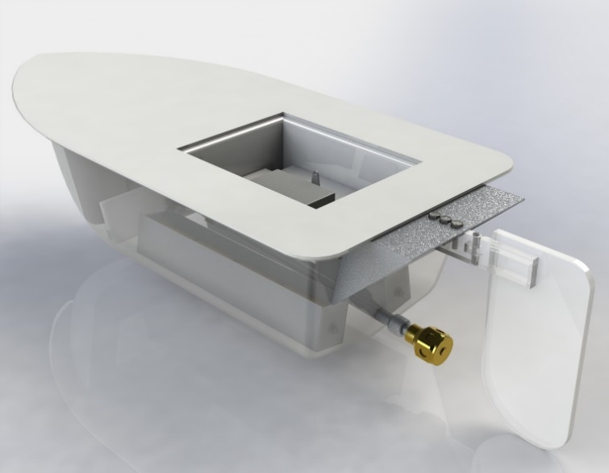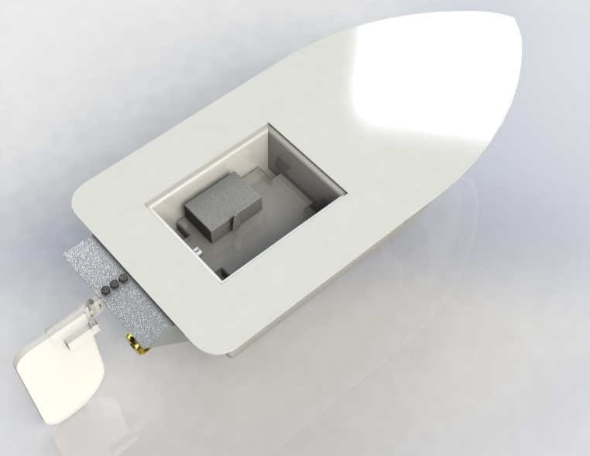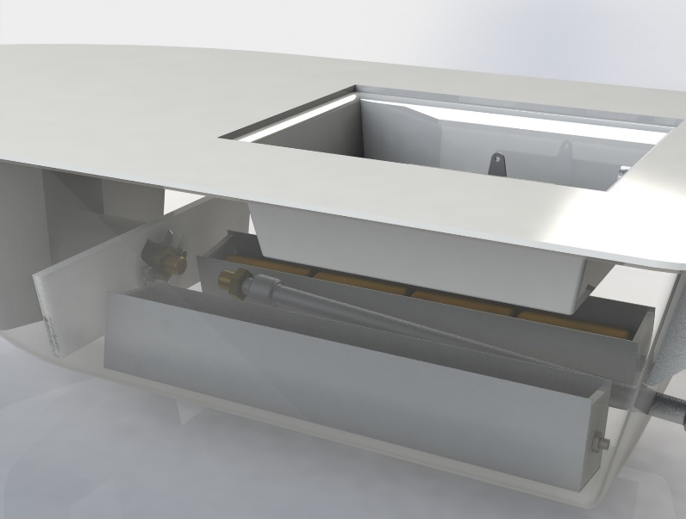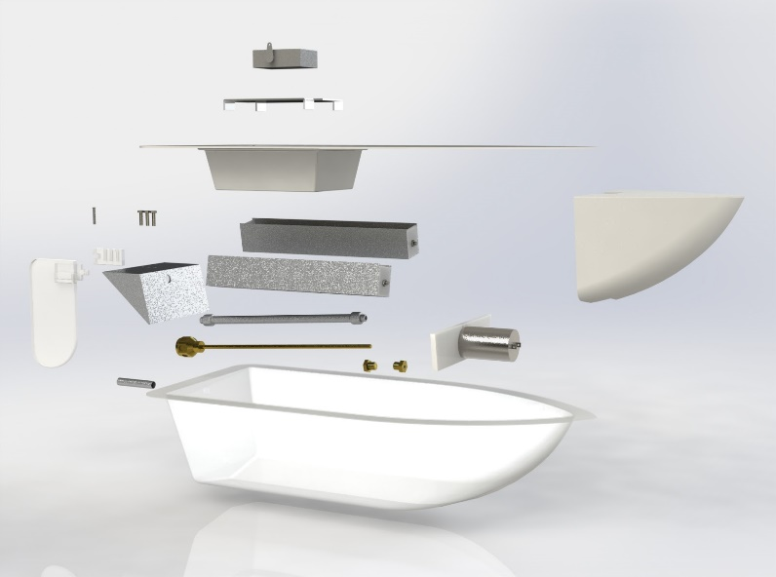

# 6COSTINGS – Tony Carpendale

6.1 Materials and Budgeting

Accounting for cost and budgeting is a large part of project management. Project cost management helps people to monitor costs throughout the project build and helps with decision making around unexpected or unforeseen situations when they arise. As part of syndicate E’s boat building process, different strategies were used to ensure we remained on task. One of those strategies was keeping a record of outgoing cost. This allowed us to know exactly how much budget we had remaining at any one time. This helped when it came to developing additional design elements for each section of the boat by simply knowing we had enough budget to do so.

During the syndicate meetings prior to the first lab build session, considerations of design elements and construction techniques had been discussed. For example, which hull we should use, which steering system we should use and how will we go about building the catchment device. Factors like build time, cost of materials were taken into account. The budget allowance for syndicate E’s project build was $210 from Brett’s Bargain basement. This had influence on some of the design features of the boat for cost reasons. For example, feasibility of having a catamaran would have increased the stability of the vessel and made the collection device easier to manufacture by incorporating it between the two hulls, however the extra added cost of having two motors, two drive units and two rudders could have potentially exceeded the budget. Plans were made during the syndicate meetings as how to incorporate each of the components and make them fit together in a cohesive manner, this was done with intentions to have enough budget remaining to adsorb any unforeseen mistakes or miscalculations.

Throughout the build process a budget spread sheet for materials used was kept up to date, this informed how much budget had been spent and what it had been spent on. This was vital as avoidance to this may have resulted in exceeding the budget. Consequently, this may have incurred a loss of points penalty on race day.

**Table 1: Budget Spread Sheet Materials and Parts**

|  |  |  |  |  |
| --- | --- | --- | --- | --- |
| **Construction materials** | | **Price per unit** | **Quantity** | **Sub total** |
| **237** | 3.3 Corflute | $ 1.61 |  | $ - |
| **236** | 4mm Shock cord | $ 0.29 |  | $ - |
| **230** | Bird Netting (16mm mesh, 4m wide) | $ 0.34 | 1 | $ 0.34 |
| **139** | Extruded flat bar | $ 0.31 |  | $ - |
| **138** | Extruded round bar 305 long | $ 0.13 | 1 | $ 0.13 |
| **240** | Extruded round bar 600 long | $ 0.26 | 2 | $ 0.52 |
| **185** | Extruded tee section | $ 0.87 | 1 | $ 0.87 |
| **229** | Foam block #4 | $ 2.35 | 1 | $ 2.35 |
| **228** | Gutter bristles | $ 5.21 |  | $ - |
| **231** | Hexagonal wire netting | $ 0.86 | 5 | $ 4.30 |
| **114** | Plastic strip, 6mm PTEG | $ 0.94 | 4 | $ 3.76 |
| **129** | Sheet metal, 0.7 Alloy | $ 0.94 | 5 | $ 4.70 |
| **109** | Tube Silicon rubber | $ 1.35 | 1 | $ 1.35 |
| **128** | Tube 1/4 OD alloy 200 long | $ 0.25 |  | $ - |
| **239** | Tube 1/4 OD alloy 600 long | $ 0.74 | 4 | $ 2.96 |
| **108** | Tube 3/8 OD Alloy 300 long | $ 0.56 | 1 | $ 0.56 |
| **214** | WCT hatch, size D | $ 0.69 | 1 | $ 0.69 |
| **Moulding Materials** | |  |  |  |
| **175** | Sheet plastic, 1.0mm PTEG, Transparent | $ 7.43 | 1 | $ 7.43 |
| **2** | Sheet plastic, 2.0mm TPS, White | $ 6.00 | 1 | $ 6.00 |
| **Fasteners and Adhesives** | |  |  |  |
| **206** | Adhesive tape, single sided transparent | freebie | 1 |  |
| **182** | Adhesive, green Stick@ craft glue | freebie | 1 |  |
| **184** | Adhesive, liquid nails clear | $ 10.00 | 1 | $ 10.00 |
| **235** | Cable ties | freebie | 1 |  |
| **222** | Hinge blank half long | $ 0.55 | 1 | $ 0.55 |
| **207** | Hinge blank half standard length | $ 0.31 |  | $ - |
| **115** | M4 nut, flanged non- serrated | freebie | 4 |  |
| **140** | M4 nut nylon locking flanged non- serrated | $ 0.14 |  | $ - |
| **225** | M4 screw 16mm long | $ 0.09 | 18 | $ 1.62 |
| **203** | M4 screw 8mm long | freebie |  |  |
| **123** | M4 set screw 6mm long | $ 0.08 | 1 | $ 0.08 |
| **159** | M4 studding, zp | $ 0.18 | 2 | $ 0.36 |
| **117** | M4 washer, wide, nylon | $ 0.15 |  | $ - |
| **233** | M4 wing screw 16mm long | $ 0.73 |  | $ - |
| **226** | M4 x 20 Hexagonal spacer, brass | $ 0.64 |  | $ - |
| **234** | String | freebie | 1 |  |
| **Steering** | |  |  |  |
| **167** | 9mm x 2mm Push rod bush, nylon | $ 0.99 | 2 | $ 1.98 |
| **218** | Base plate | $ 1.26 | 1 | $ 1.26 |
| **213** | Cable ferrule | $ 0.08 |  | $ - |
| **212** | Cable liner, 0.89.. Bore | $ 0.10 |  | $ - |
| **211** | Cable, 0.81mm diameter nylon coated | $ 0.24 |  | $ - |
| **45** | Kwick link clevis fit to M2 push rod | $ 1.61 | 2 | $ 3.22 |
| **44** | Push rod M2 thread one end | $ 1.16 | 1 | $ 1.16 |
| **215** | Rc receiver & battery | freebie | 1 |  |
| **43** | Servo horn, type J | $ 0.86 | 1 | $ 0.86 |
| **42** | Servo, standard (futaba S3003) | $ 30.00 | 1 | $ 30.00 |
| **Electrical** | |  |  |  |
| **137** | Battery (C-size) | freebie |  |  |
| **227** | Battery spring contact | $ 1.50 |  | $ - |
| **176** | Electrical cables, black and red pair | $ 0.83 | 2 | $ 1.66 |
| **232** | Micro switch | $ 3.42 | 1 | $ 3.42 |
| **131** | Motor | $ 20.00 | 1 | $ 20.00 |
| **177** | Red crimp connector female 4mm | $ 0.50 |  | $ - |
| **238** | Red crimp connector, female spade | freebie |  |  |
| **178** | Red crimp connector, M4 ring | freebie |  |  |
| **179** | Terminal block 2way | $ 0.95 | 2 | $ 1.90 |
| **52** | Terminal block 5way | $ 1.87 | 2 | $ 3.74 |
| **Propulsion** | |  |  |  |
| **147** | Drive shaft kit | $ 35.00 | 1 | $ 35.00 |
| **154** | Drive shaft, 4.76 diameter brass | $ 1.89 | 1 | $ 1.89 |
| **216** | Propeller blades | $ 3.00 | 3 | $ 9.00 |
| **Consumables** | |  |  |  |
| **155** | Drill bits, 1mm -6.5mm | $ 1.20 |  | $ - |
| **Replacement Parts** | |  |  |  |
| **187** | #4 screw 5/16 long self-tapping | $ 0.09 | 4 | $ 0.36 |
| **219** | Backing washer | $ 0.10 |  | $ - |
| **220** | Conforming washer | freebie |  |  |
| **113** | Drive shaft bearing | $ 8.53 |  | $ - |
| **224** | Grease port seal | $ 0.12 |  | $ - |
| **209** | M3 Screw 10mm long | $ 0.25 |  | $ - |
| **31** | M3 x 3mm set screw | $ 0.25 |  | $ - |
| **166** | M4 x 4mm set screw | $ 0.50 |  | $ - |
| **221** | M5 Screw 16mm long | $ 0.12 |  | $ - |
| **223** | M5 x 6mm set screw | $ 0.12 |  | $ - |
| **200** | Motor mounting plate | $ 1.00 |  | $ - |
| **217** | Propeller boss | $ 8.50 |  | $ - |
| **103** | Universal joint insert, 3.2mm bore | $ 10.40 |  | $ - |
| **157** | Universal joint insert, 4.76mm bore | $ 10.40 |  | $ - |
| **Design fixes** | |  |  |  |
| **194** | 14oz ballast with self-adhesive tape | $ 2.00 | 1 | $ 2.00 |
|  |  |  |  |  |
|  |  |  |  |  |
|  |  |  |  |  |
|  |  | **Budget Spent:** |  | $ 166.02 |
|  |  | **Total Budget:** |  | $210.00 |
|  |  | **Budget Remaining:** |  | $43.98 |

Budget spreadsheet (refer to Table 1) – a conscious effort was made in purchasing only required materials and accounting for these materials with a spread sheet. The spread sheet shows the parts and the part numbers, the price per unit, the quantity purchased and the subtotals and totals spent over the duration of the build. The spreadsheet was updated after every purchase order submission. The remaining budget after the completion of the build was $43.98.

6.2 Accounting for Hours and Labour cost

|  |  |
| --- | --- |
|  | Design Time  (h) |
| **Rudders and Steering** | 3.5 |
| **Motors and Props** | 2 |
| **Hull and Water Tight Compartment** | 1 |
| **Battery Packs** | 2 |
| **Collection Device** | 2 |
| **Total** | **10.5** |

**Table 2: Design Labour**

Design labour (refer to Table 2) – this table shows design hours carried out within syndicate members own personal time. Syndicate members will be paid for their design time.

|  |  |  |  |  |  |
| --- | --- | --- | --- | --- | --- |
|  | Members Present | Managers Present | Time  (h) | Members (h) | Managers (h) |
| **10 April** | 6 | 2 @ 60min | 2 | 12 | 2 |
| **1 May** | 7 | 1 @ 60min | 2 | 14 | 1 |
| **8 May** | 8 | 1 @ 60min | 2 | 16 | 1 |
| **15 May** | 8 | 2 | 2 | 16 | 4 |
| **22 May** | 6 | 2 | 2 | 12 | 4 |
| **25May** Testing | 2 | 2 | 1 | 2 | 2 |
|  |  |  | **Total (h)** | **72** | **14** |

**Table 3: Build Time in Labs**

Build time in labs (refer to Table 3) – This table shows labour hours for both syndicate managers and members. Note: for the first three build labs the managers were present for one of the two allocated hours.

|  |  |  |  |  |  |
| --- | --- | --- | --- | --- | --- |
|  | Members Present | Managers Present | Time  (h) | Members (h) | Managers (h) |
| **7 March** | 7 | 2 | .75 | 5.25 | 1.5 |
| **14 March** | 5 | 1 | .75 | 3.75 | .75 |
| **21 March** | 3 | 1 | .75 | 2.25 | .75 |
| **28 March** | 6 | 1 | .75 | 4.5 | .75 |
| **4 April** | 6 | 1 | .75 | 4.5 | .75 |
| **11 April** | 5 | 1 | .75 | 3.75 | .75 |
| **2 May** | 5 | 2 | .75 | 3.75 | 1.5 |
| **9 May** | 4 | 2 | .75 | 3 | 1.5 |
| **16 May** | 6 | 2 | .75 | 4.5 | 1.5 |
|  |  |  | **Total (h)** | **35.25** | **9.75** |

**Table 4: Syndicate Meetings**

Syndicate meeting (refer to Table 4) – show hours outside of lab times to discuss various issues associated with design, strategy, build process, etc.

|  |  |  |  |
| --- | --- | --- | --- |
|  | Hours of Labor  (h) | Pay rate  ($/h) | Cost of Labor  ($) |
| **Syndicate Members** | 117.75 | 18 | 2119.5 |
| **Syndicate Managers** | 23.75 | 24 | 570 |
| **Cost of materials** |  |  | 166.02 |
|  |  | **Total Cost ($)** | **2855.52** |

**Table5: Cost of Build, Design, Labour, Meetings and Materials**

Final cost of the build (refer to Table 5) – shows overall hours and total cost of the build for syndicate E’s prototype, this is inclusive of design, labour, meetings and materials.

6.3 Mass Production

The cost associated with producing Syndicate E’s prototype boat is inclusive of design, materials, manufacture, and testing. Each section having its own associated costs. If the process of making RC boats was scaled up to make 100’s of boats the unit price per boat would definitely change.

First before considering the unit price change, there need to be some assumptions made.

1. Assuming the production of 100’s of boats excludes design.
2. Assuming the production of the boats excludes testing.
3. Assuming the price of the materials and parts become discounted with through bulk ordering.
4. Assuming the manufacture of the boats were to be carried out on a production line.

In negotiation with Brett from Brett’s Bargain Basement his company has agreed to supply all of the items to Syndicate E at a discounted rate through bulk ordering. Considering the unit price for everything on the parts list is subject to change, an agreed discount rate has been averaged over the entire parts list at a discount rate of 30%.

The cost of materials associated with team E’s prototype was $166.02. The new discounted cost of materials will be $166.02 - 30% = $116.21 per unit.

Labour cost associated in manufacturing will significantly reduce due to the process being completed on a production line. Estimated savings will be 50% less per unit price. The labour cost to produce Team E’s prototype was $1296.00. The new estimated cost is 50% less, $648.00/ unit labour.

|  |  |
| --- | --- |
|  | ($) |
| **Labor Cost** | 648.00 |
| **Materials and Parts** | 116.21 |
| **Total Cost/ Unit** | **764.02** |

**Table 6: Cost per unit of Mass Production**

NOTE: This unit price remains substantially high. If the manufacturing was to be scaled to thousands or hundreds of thousands of units, the price/unit would continue to decrease due to improved efficiency in production and greater discount prices on materials and parts.

Total cost of mass production price /unit (refer to Table 6) – shows the cost of mass producing 100’s of boats, based on the assumptions stated above. This price is based solely on price of materials and labour cost. It does not take into account design and testing cost.

# 7ENVIRONMENTAL CONSIDERATIONS– Sultan Al-Habsi & Alaa Eldin Abuellif

Waste arising in production processes can have a significant effect on the environment. The challenge is to reduce waste in the production stage without affecting the efficiency of the boat. Typical problems include the use of excessive energy and raw materials, which will lead to losses in the production process itself and finally the failure when using the end product. A great way to minimize the environmental impact is to improve the method used to build the boat or the collection system. This can be done by using modern techniques and strategies to find the best building process. After finding the best technique, it is an essential part to choose the best materials to work with. To minimize the waste during manufacturing, it would be important to use environmentally friendly material which means using disposable and recyclable materials such as recyclable plastic. Because the boat will work on water, it is important to ensure that if the boat sunk or for some reason got lost, it will not be any danger to the environment. Another idea that can be done is being strict on ordering the exact amount of materials needed while manufacturing the boat. Therefore, there will be no extra leftovers and therefore less impact on the environment. However, if there were leftover materials a great technique would be to reuse those materials again by first collecting them. Then, sending the materials to the factory or the production company to be recycled and finally use them again in the boat.

Another way to reduce the environmental impact during manufacture is using durable and long-lasting materials. If the boat was durable enough, there will be no need to repair it. Therefore, there will be no need to create more waste to deal with in the first place.

In conclusion, using the three Rs to minimize environmental impact is important. They are: reduce, reuse and recycle. Ordering the exact amount of material to build the boat will help to minimize wastes. Then, it will be important to deal with the remaining by reusing the parts to build another project or to modify the same product. Finally, recycling is essential to keep the environment safe. (Sultan)

As we do any project we must put into consideration the effects on the environment that this experiment or project could result in. We as a result try to minimise that risk and keep our future waste free. Recycling in a huge factor when it comes to waste control, its used everywhere and by everyone. In our project we had to collect plastic waste containers from the university lake. The easiest way behind recycling plastic and the majority of waste is heat compression thought, it would have to be monitored and done properly to avoid air pollution, the boat however could be used as a prime example for a winning boat prototype for the next years. The servo and all the interior will be reused. Batteries on the other hand are tricky and will have to be disposed of or recycled the right way. Batteries have harmful chemicals and compounds that can pollute the environment for a very long time and it becomes a huge problem when tones are produced worldwide every day, and the demand keeps rising. (Alaa Eldin)

# 8PERFORMANCE APPRAISAL– Lee Oldfield

On the 2nd of June 2018, the ENGEN180-18A boat race took place on the Oranga Lake at the University of Waikato. Group E has produced one boat which will compete in the race series. At the beginning of the paper, each group participated in different experiments which gave them a few tips and hints as to what worked best and why.

Nevertheless, our team went into the 5th race of the first heat knowing that we had put in a good effort and were hoping to get the results. With Lee steering us in our first heat and Tony ensuring a good start and helping with the collection of our plastic bottles/containers, team Egypt started well. We set out ahead of all other teams, with the advantage of a quick boat Lee managed to collect 58 points worth of rubbish in the first heat. Thus, putting us in 2nd place.

Our second race was the last race of the 2nd heat. Still sitting in 2nd place we went into our heat with high hopes. With a slight difficulty in the steering system during heat 1, Lee and Tony managed to quickly fix this before the race started. With Lee at the helm again and Tony at his side, team Egypt managed to come away with the highest score so far at 85 points.

With the top 9 scores going through to quarterfinals, we were sitting in a very comfortable position. In the quarter final, some minor adjustments were made to the collection device and team Egypt were under way. To share the work, Aladdin replaced Tony for this race. Again, Egypt was out to a flying start which allowed for time to manoeuvre around the course for the 2-point bottles. With 2 trips there and back and 40 seconds to spare, Egypt came away with 92 points which held us at the top of the table.

Going into our semi-final with high hopes we encountered a steering issue.

As Lee and Tony replaced our 16 C Cell batteries, Brett the technician tried to resolve our issue with the radio gear. After changing all components but the servo we still had no luck. We thought our racing was over. Brett then tried another groups radio gear and managed to get our steering system back under way. We then got placed into the next semi-final which again we scored very well at a whopping 102 points.

Heading into the finals we were up against Austria who had also performed very well through the series. With Lee at the helm and Tony there to help, we were ready to race. As the race began Lee headed straight out the back to do a big collection run on the way in. With a very reliable boat he manged to complete 3 full runs and once again finish with an extremely good result of 102 points which won team Egypt the 2018 Boat race. As a team we were very happy with the outcome of the race series. To progress through to the finals and win the final was a big achievement for the team and goes to show the amount of effort put in by the syndicate and syndicate managers.

The last race of the day was the student’s vs staff race. Again, another set of batteries were supplied and Lee and Tony set out seeking for the win. With a quick start and a field worth of points concentrated into a small area, team Egypt managed to gather 70% of the field in one run alone. With a very competitive opposition, we managed to gather a few more bottles which totalled up to 148 points. Again, the team were very happy with this result which topped off our extremely successful race series.

Hull Team

One of these stations was the hull drag/balance testing. The 4 boats that were available to us were all tested on the water flow machine and the drag was recorded. After analysing these results, group E came to the conclusion that hull design #3 was going to be the best selection. Overall, the hull chosen was very effective and served us very well, however a slightly more hydrodynamic hull would have moved faster through the water, and in return allowed us to collect more waste and gain more points. We feel that Dion did a very good and efficient job with the vacuum forming of both the hull and water tight compartment. Once completed, Dion shaped the polystyrene block to fit snugly in the bow of the boat which he did a very good job of also.

Steering Team

In our opinion, there is nothing that could have been done to the steering system to improve it. It worked very well and was a key factor in our success, it provided effective turns which allowed Lee to easily navigate around and collect waste for points. Overall both Lee and Tony both worked very effectively finishing the assembly in just 2 1/2 build sessions. After completion they both contributed in all parts of the project, their help and input was crucial to ensuring we had a boat to race on the day and that it was going to be successful. Their steering system and rudder design was undoubtedly one of the most crucial aspects of the boat projects success.

Battery Team

Regarding the battery system, Kieran designed 2 battery packs, each holding 8 C cell batteries. The two packs were wired up in parallel which allowed us to only run 8 if necessary. Kieran’s decision to use 2 battery packs was good as it helped maintain an even weight distribution throughout the boat and a long-lasting voltage supply. It is hard to tell if the increased amount of batteries actually increased the overall speed of the boat. By using more batteries, we supplied a greater voltage to the motor but was this supplied voltage overcoming the weight of the battery’s themselves? More testing is required to judge this; therefore, it is hard to tell. Team Egypt feels that Kieran communicated effectively with both syndicate managers in ensuring his design was going to be fit for purpose and reliable on race day.

Propulsion Team

The propulsion system was also very impressive and was a crucial factor in our ability to attain a fast boat. Another experiment that was completed by each team was the propeller pitch experiment which tested the amount of force a drive assembly had when the pitch of the blades was changed. Nashlin and Rojena considered many factors when choosing the amount of propeller blades and the pitch that they were on. However, it is possible that fine tuning of the propeller blade pitch may have increased the boats top speed on race day but it is hard to tell without more time and experimentation with our own unique boat. We feel that Nashlin and Tony (Rojena was no longer enrolled in the course) did an excellent job of designing this system. Tony’s work ethic was admirable which again ensured our boats success on race day. Nashlin’s input to the team is greatly appreciated through her willingness to help with construction where possible and her positivity during the build labs.

Collection Team

The collection system that was designed and constructed by both Sultan and Alaa Eldin was admirably one of the most effective collection systems in the race series. The team feels that Sultan and Alaa Eldin’s design of the collection system was a key factor in our success. With two hydrodynamic cylinders down each side of the boat and a flaring net at the front, the collection system was able to hold around 50 points worth of plastic in just one run alone, this is more than 15 other teams could collect in a total of 5 mins. As a result, the collection system served team Egypt very well and we feel that this is down to the time spent by both members designing and perfecting the collection system. Both Sultan and Alaa Eldin were very efficient each build lab and their knowledgeable input into other aspects of the build were vital.

Special Mentions

Special thanks must go to Lee and Tony for making sure the boat was 100% ready during the extra hour that was given at the end of the build labs. Also to Nashlin, as the fact that Nashlin’s partner on the motors and propulsion section left halfway through the semester. As well as to both Nashlin and Tony for the painting of the boat which they did a great job of. Also, a special thanks to Lee, Tony and Aladdin for ensuring that the boat was prepared and performed to the best of its ability in each race throughout the course of the day. Last but not least a big thankyou to Dion Herniman for taking on the responsibility of collating the final report.

Manager Appraisal

Ben Thornton and Russell Keenan were the syndicate managers for Team Egypt. As a team we feel that both of their guidance was valuable in ensuring our success on race day. Ben and Russell ran productive weekly meetings, created agendas and were present for 95% of the build time to guide us in the right direction. Their assistance with the boat project was greatly appreciated by the entire team and we are thankful for their guidance. Perhaps one improvement would have been to create some sort of Gantt chart or flow diagram to show where we were sitting at each lab and what needed to be completed. This was discussed in meetings but a chart itself may have helped with the efficiency of all members for the entire lab time.

Reflection & Review

The aim of the 2018 boat project was to construct a boat to collect waste in the Oranga lake within a given period of time, 5 build labs, and a budget of $210. As shown above, our group managed to keep well under budget due to minimal waste and effective designs with no trial and error. Although we managed to stay well under budget, time was big factor in our build labs. When it came to fitting all components back into the boat, it took a lot longer than our group expected which resulted in us using the extra 1 hour catch up lab which was all we needed. Better time management in a couple build labs prior may have avoided relying on extra time at the end of the project. Despite this, Egypt managed to compete on race day and win the competition.